**DOOR LOCKING SYSTEM**



**Presented to:**

**Dr. Tariq Saddad**

**Presented By:**

Mobeena Ramzan (3868-FBAS/BSCS/F18-B)

Laiba Bint-E Mazhar (3870-FBAS/BSCS/F18-B)

**Department of Computer Science and Software Engineering**

**International Islamic University, Islamabad**

**Door Lock System**

Security is the main thing in this modern world because as the technology is developing the thieves are also increases as the time passes. Secure security is important because you don’t want anyone to enter in your home.

There are many types of security systems present today for authentication they all relay behind the scenes on fingerprint, retina scanner, iris scanner, face id, tongue scanner, RFID reader, password, pin, patterns, etc. People always prefer the things which are more functional and of low cost so out of all the solutions the password or pin-based system is the best one to fit in this criterion.

# What project will do?

* Open the door only if the password is right.
* If the password is wrong then wrong password will be shown on lcd.
* If the password gets wrong 3 times consecutively then the buzzer will trigger on and will not turn off until you press the button in the system.
* If you try to enter the * or the # then it will show the message wrong password on lcd without waiting for you to finish the count of the password and then show the message.

# Features:

So, in this project, I have built an Arduino Keypad Door Lock system simulation on the Proteous which can be fitted in to any of your existing doors to secure them with a digital password easily. In this system the door will open if the password enter on the keypad is correct otherwise the door will not open in any case. The system will only give you three chances too enter the password only. It will give you three chances to enter the right password but if you enter the password wrong third time then the door alarm will turn on and start buzzing and also lock the door automatically permanently. The door will not open and won’t stop the alarm until you call and professional who know the lock to press the secure button present inside the system. Only then it gets unlock and also alarm will stop buzzing. In this system while you enter the password you have to do it one character at a time and the digits will only show on the screen for only one seconds and then digit will disappear and you will enter the next digit and so on. This system has also one important function that after you open the password with the right password the door will automatically close the door in some seconds and again you have to enter the right password to get in the house.

In this project the door lock system is made using and Arduino board on a proteous as a simulation. The circuit components and working are mentioned below:

# Components:

Following are the components used in the project:

* 3WATT10K
* 3WATT220R
* ARDUINO UNO
* BC547BP
* BUTTON
* BUZZER
* KEYPAD-PHONE
* LED
* LED-GREEN
* LED-RED
* LM044L
* MOTOR
* PCF8574A
* SWITCH

# Components Details:

**Resistors:** A resistor is a passive two-terminal electrical component that implements electrical resistance as a circuit element. In electronic circuits, resistors are used to reduce current flow, adjust signal levels, to divide voltages, bias active elements, and terminate transmission lines, among other uses.

Here we have used 2 kind of resistors:

* 3WATT10K (resister of 3 watt and of 10K power)
* 3WATT220R (resister of 3 watt and of 220R power)

**ARDUINO UNO:** Arduino UNO is a low-cost, flexible, and easy-to-use programmable open-source microcontroller board that can be integrated into a variety of electronic projects. This board can be interfaced with other Arduino boards, Arduino shields, Raspberry Pi boards and can control relays, LEDs, servos, and motors as an output.

**BC547BP:** A small current of the base terminal of this transistor will control the large current of emitter and base terminals. The main function of this transistor is to amplify as well as switching purposes.

**BUTTON:** The pushbutton is a component that connects two points in a circuit when you press it.

**BUZZER:** An arduino buzzer is also called a piezo buzzer. It is basically a tiny speaker that you can connect directly to an Arduino. You can make it sound a tone at a frequency you set.

**KEYPAD-PHONE:** A traditional cell phone keypad, or keypad on any phone, is generally designed in a 3 x 4 pattern. This means that there are four horizontal rows, each including three buttons. The fourth row includes the asterisk and pound sign buttons.

**LED:** LEDs are small, powerful lights that are used in many different applications. It is as simple as turning a light on and off.

We are using 2 types of led in this project

* LED-GREEN:
* LED-RED:

**LM044L:** It will show the output on the screen. The digitalWrite() function is used to write a HIGH or a LOW value to a digital pin. If the pin has been configured as an OUTPUT with pinMode().

**MOTOR:** If you connect these two leads directly to a battery, the motor will rotate. If you switch the leads, the motor will rotate in the opposite direction.

**PCF8574A:** The PCF8574A device provides general-purpose remote I/O expansion for most microcontroller families via the I2C interface [serial clock (SCL), serial data (SDA)].

**SWITCH:** An if statement allows you to choose between two discrete options, TRUE or FALSE. When there are more than two options, you can use multiple if statements, or you can use the switch statement. Switch allows you to choose between several discrete options.

# Code:

These are all the libraries that we are going to use for this project. Keypad is a library for using matrix style keypads with the Arduino, Wire.h library allows you to communicate with I2C / TWI devices and LiquidCrystal_I2C.h library for I2C LCD displays.

|  |
| --- |
| #include<Keypad.h>  #include <Wire.h>  #include <LiquidCrystal_I2C.h>  LiquidCrystal_I2C lcd(0x3F,20,4); |

Keys have the value that will go for the keypad-phone with the star and the hash value to enter. Then the rowPin and colPin will have the pin numbers of the ardino that they will be connected to. Then in the password variable will have the official password of the door. The all the variables will be declared to use later.

|  |
| --- |
| char keys[4][3]={  {'1','2','3'},  {'4','5','6'},  {'7','8','9'},  {'*','0','#'}};    byte rowPin[4]={6,7,8,9};  byte colPin[3]={3,4,5};  String password = "4567"; // The Pin Code.  int position = 0;  int wrong = 0; // Variable to calculate the wrong inputs.  int redPin = 10;  int greenPin = 11;  int buzzer = 12;  //Keypad keypad = Keypad( makeKeymap(keys), rowPins, colPins, rows, cols );  Keypad keypad=Keypad(makeKeymap(keys),rowPin,colPin,4,3);  // MAPPING THE KEYPAD.  int total = 0; // Variable to determine the number of wrong attempts. |

This functon will help us to set the main components of the project like ledRed and ledGreen to indicate whether the door is open (redLed) or close (greenLed) and the lcd that what content on what time will be shown on the lcd like the intro of the maker and project. setup function will also manage state of the password

|  |
| --- |
| void setup()  {  //pinMode(pin, mode)  pinMode(redPin,OUTPUT); //door close  pinMode(greenPin,OUTPUT); //door open  pinMode(buzzer, OUTPUT); //buzzer    lcd.init(); //initialize the lcd  //lcd.init();  lcd.backlight(); //LCDs do not produce light by themselves  lcd.print(" 4x3 ");  lcd.setCursor(0,1); //lcd.setCursor(col, row)  lcd.print(" Locking System ");  lcd.setCursor(0,2);  lcd.print(" By: Keypad ");  lcd.setCursor(0,3);  lcd.print(" Mobeena Ramzan ");  delay(3000);  lcd.clear();  setLocked(true); //state of the password  delay(20);  } |

With the help of loop() function it is going to take the password word by word. It will take a word and wait for some time and then get the 2nd password number and so on. Each time it will take a digit of a password it compares it with the password stored in memory that it is right or not. If the number is wrong then it increases the number of the wrong variable by 1 and so on. And it will increase the number by 1 of the variable position every time you enter a digit for the password and will open the door only if the position has 4 as a count in it. Every time if you press the * or # the position count will reset and the message of wrong password will appear on LCD. Then it will check that if the wrong variable is still zero and position is zero then it is correct and will send the value of false to the function setLocked() which will open the door. At last it will also check if the password has been incorrect for 3 times then it will call the function buzzer_beep() which will trigger the buzzer on.

|  |
| --- |
| void loop()  {    lcd.clear();  lcd.print(" Enter Unlock Code: ");  delay(100);    char pressed=keypad.getKey();  String key[3];    if(pressed)  {  lcd.clear();  lcd.print(" Enter Unlock Code: ");  lcd.setCursor(position,2);  lcd.print(pressed);  delay(500);  if(pressed == '*' || pressed == '#')  {  position = 0;  setLocked(true);  lcd.clear();  }  else if(pressed == password[position])  {  key[position]=pressed;  position++;  }    else if (pressed != password[position] )  {  wrong++;  position ++;  }  if(position == 4){  if( wrong >0)  {  total++;  wrong = 0;  position = 0;  lcd.clear();  lcd.setCursor(0,2);  lcd.print(" Wrong Code! ");  delay(1000);  setLocked(true);  }  else if(position == 4 && wrong == 0)  {  position = 0;  wrong = 0;  lcd.clear();  lcd.setCursor(0,1);  lcd.print(" Welcome! ");  lcd.setCursor(5,2);  lcd.print(" Door Open");  delay(2000);  setLocked(false);  }  if(total ==3)  {  total=0;  buzzer_beep();  delay(500);  }  }  }    } |

Every time of you want to open or close the door this function setLocked() will be called out with an argument passed in Boolean. If the true is passed as an argument in the funtion then a led-red will get trigger and door will close. If the false is passed as an argument in the funtion then a led-green will get trigger and door will get open and will remain open for 2 seconds. After the time gets over it will trigger the led-red again and door will get close automatically.

|  |
| --- |
| void setLocked(int locked)  {  if (locked)  {  digitalWrite(redPin, HIGH); //used to read the logic state at a pin  digitalWrite(greenPin, LOW); //enable (HIGH) or disable (LOW)  delay(1000);  }  else  {  digitalWrite(redPin, LOW);  digitalWrite(greenPin, HIGH);  delay(2000);  digitalWrite(redPin, HIGH);  digitalWrite(greenPin, LOW);  }  } |

If the password you have enter is wrong 3 times consecutively then the buzzer_beep() function will get called which will the trigger the alarm in the system that some intruder is trying to enter the door. And also, the warning message will be shown on lcd with the access denied message.

the buzzer will not go off until you press the reset button in the system.

|  |
| --- |
| void buzzer_beep()  {  lcd.clear();  lcd.setCursor(0,1);  lcd.print(" WARNING !!!! ");  lcd.setCursor(0,2);  lcd.print(" Access Denied");  for (int i=0;i<10;i++){  digitalWrite(buzzer,HIGH);  delay(1000);  digitalWrite(buzzer,LOW);  delay(1000);  }  } |

# Working:

When the door locking system will get stared and show the introduction of the system on LCD which will look like what’s in the image.

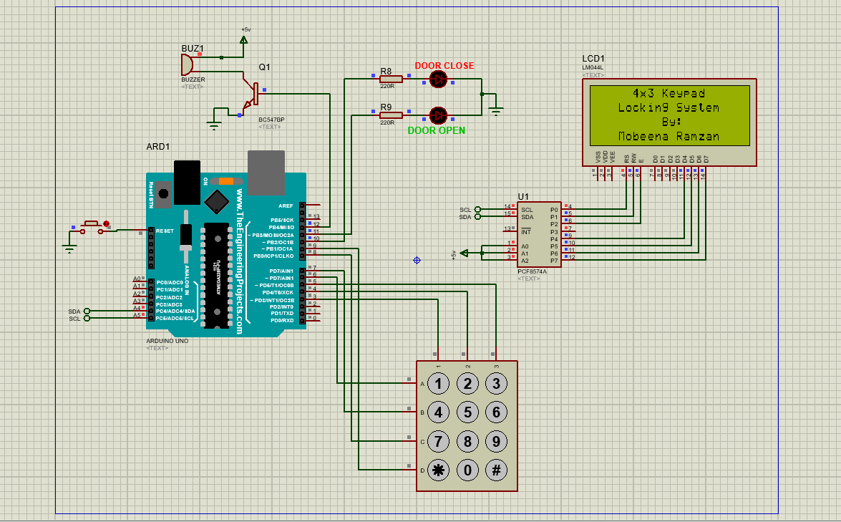

(image: 1)

Then you will enter the password number one by one by the phone keypad under the Enter Unlock Code is written. Here the password that has been set by me automatically is “4567”. We have to enter 4 first and then by the delay of some time that number will disappear so that nobody else can see it for security purposes like in image 2.

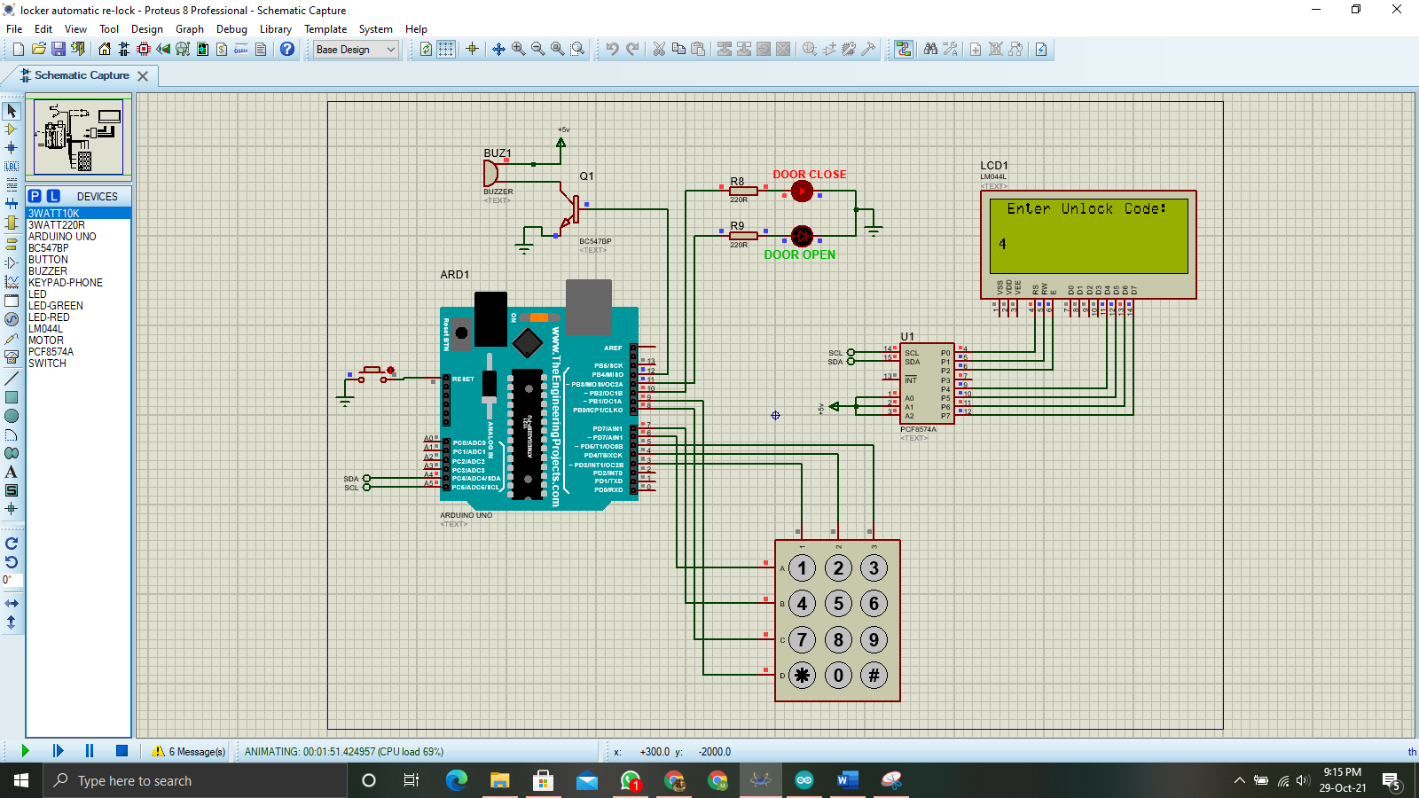

(image: 2)

Then we will enter the second number which is “5” then it will disappear then a first screen will appear again that says Enter Unlock Code to enter the next digit of password like in image 3.

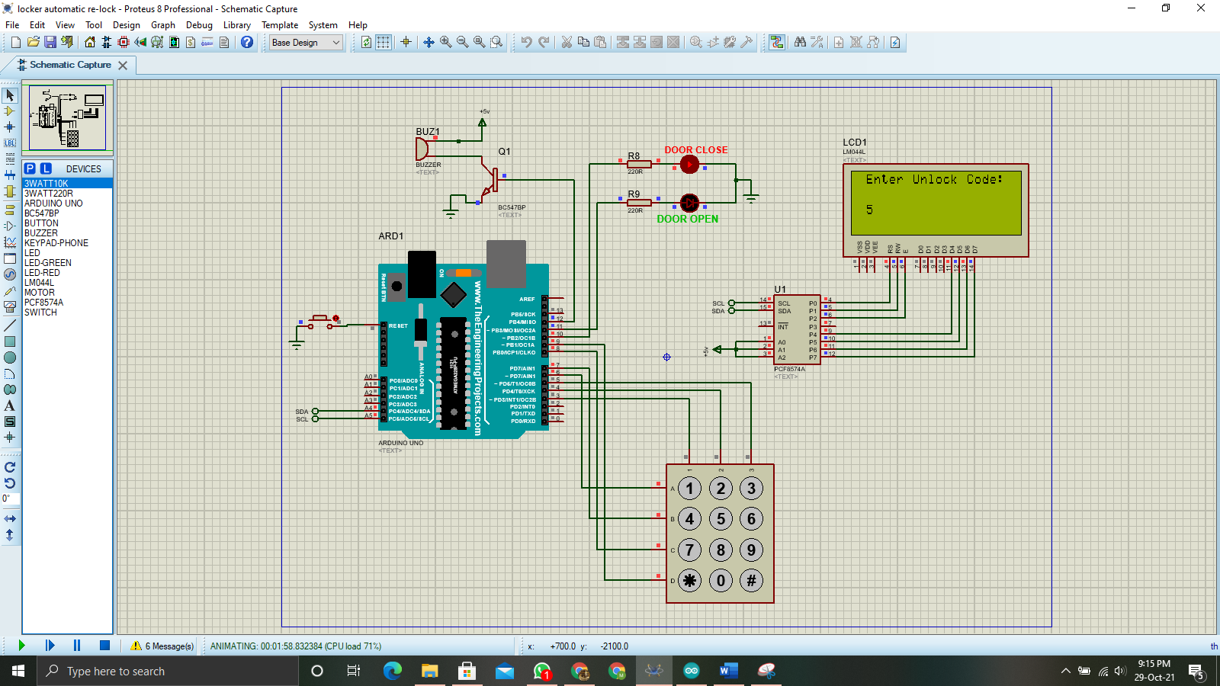

(image: 3)

Then we will enter the second number which is “6” then it will disappear then a first screen will appear again that says Enter Unlock Code to enter the next digit of password like in image 4.

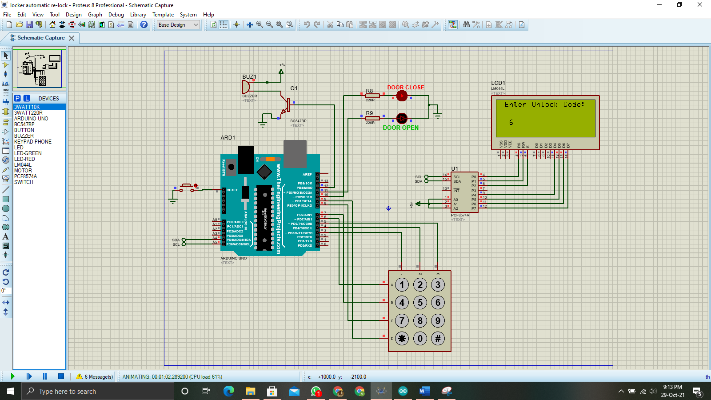

(image: 4)

Then we will enter the second number which is “5” like in image 5.

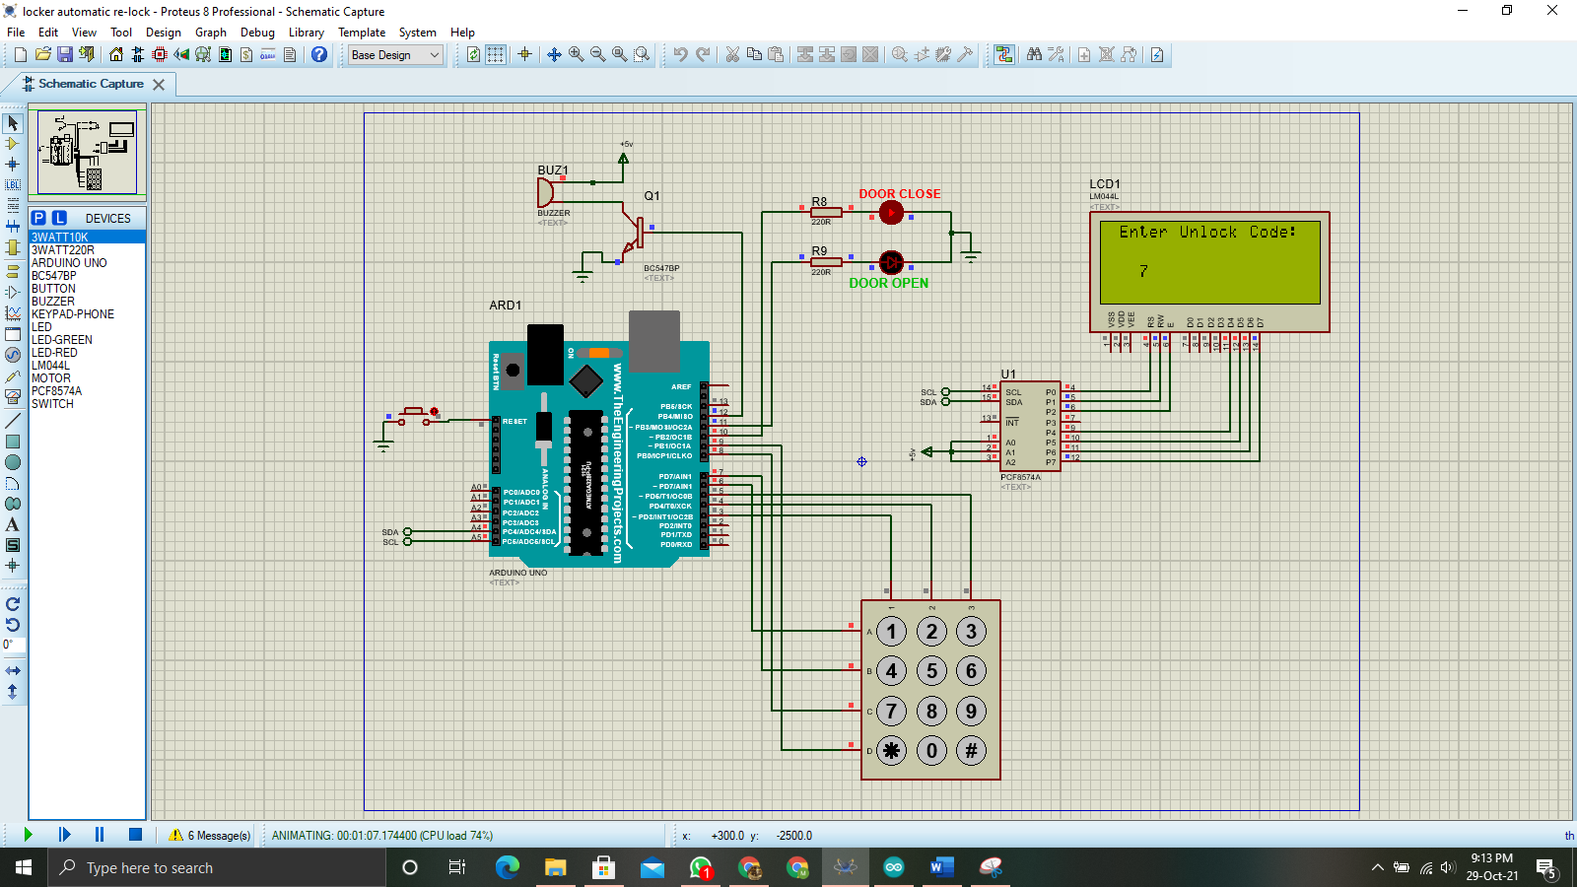

(image: 5)

After entering all four digits of the password, if the password is correct the screen will appear that says welcome: Door Open like it says in image 6. And the green-led will turn on that indicate that the door is open.

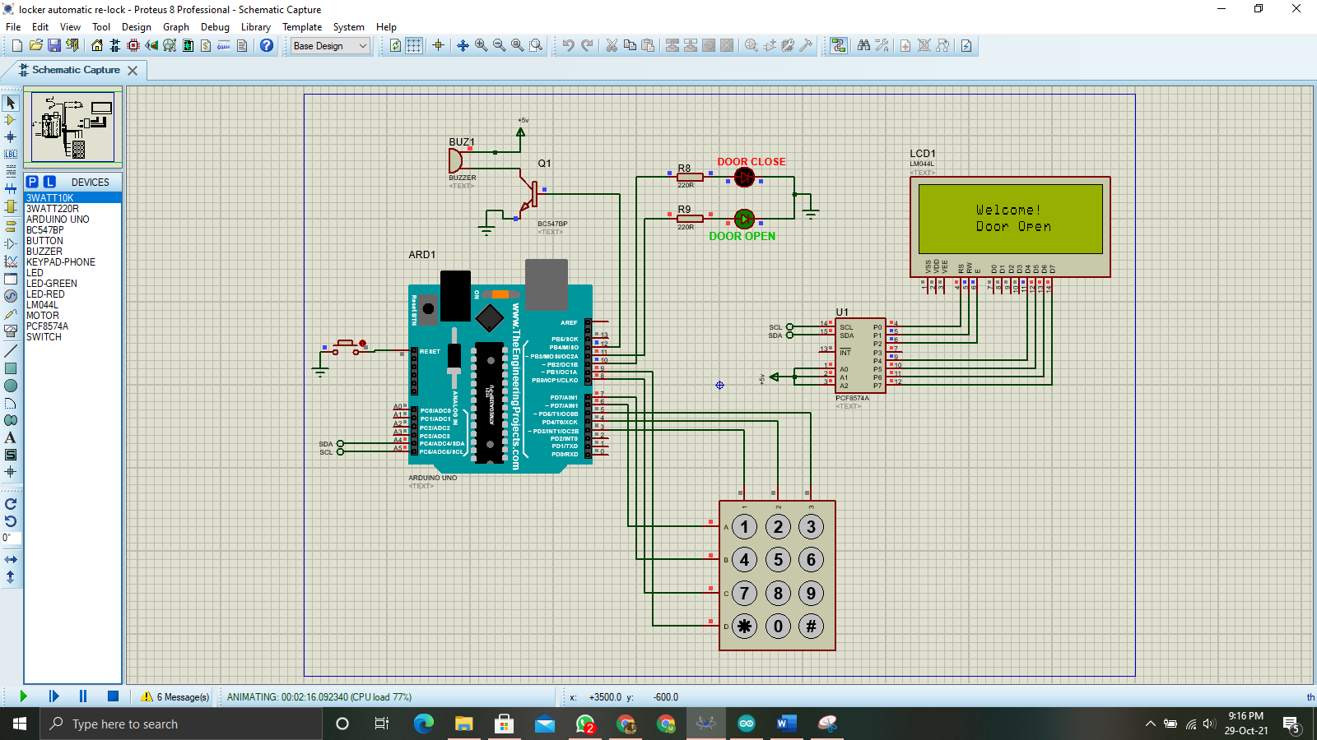

(image: 6)

If the password that you have enter is wrong or even a single digit is wrong then the lcd will says Wrong Code like in image 7. And red-led will turn on that indicate that the door is close.

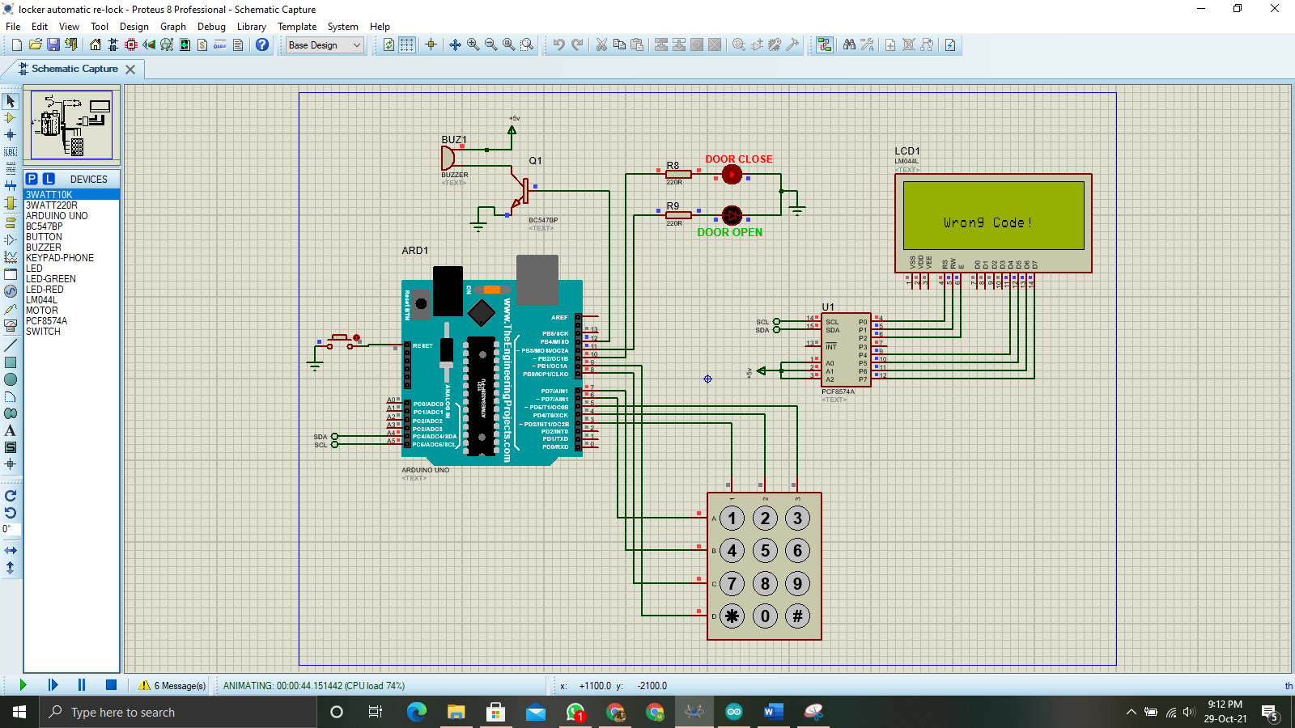

(image: 7)

If you have entered the password three times wrong consecutively then the system will get locked automatically and you will not be able to enter the door or enter the password again and it will trigger the buzzer on which will start making the sound and can attract peoples around you which and the person will be locked out of the door like it says in image 8. To open the door, he has to call a person who know the system or an engineer who will open the system and press the button on the right side of the system to reset the system.

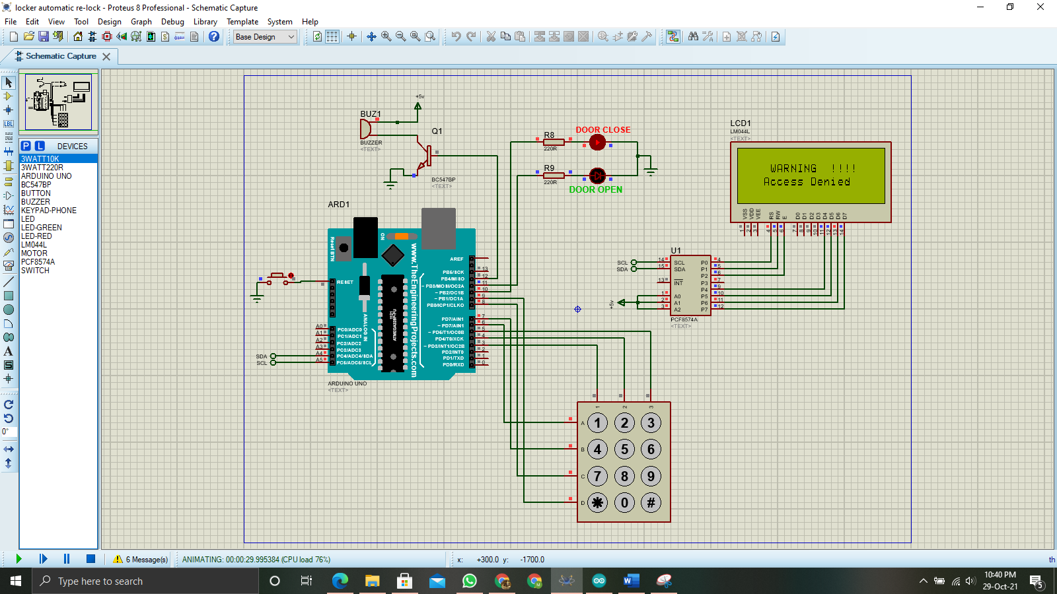

(image: 8)

If you try to enter the * or # like in image 9 which are the part of the phone_keypad but cant be a part of the password so it will automatically with taking the rest of the digit to complete the count of password it will show the message wrong password on lcd automatically like in image 7

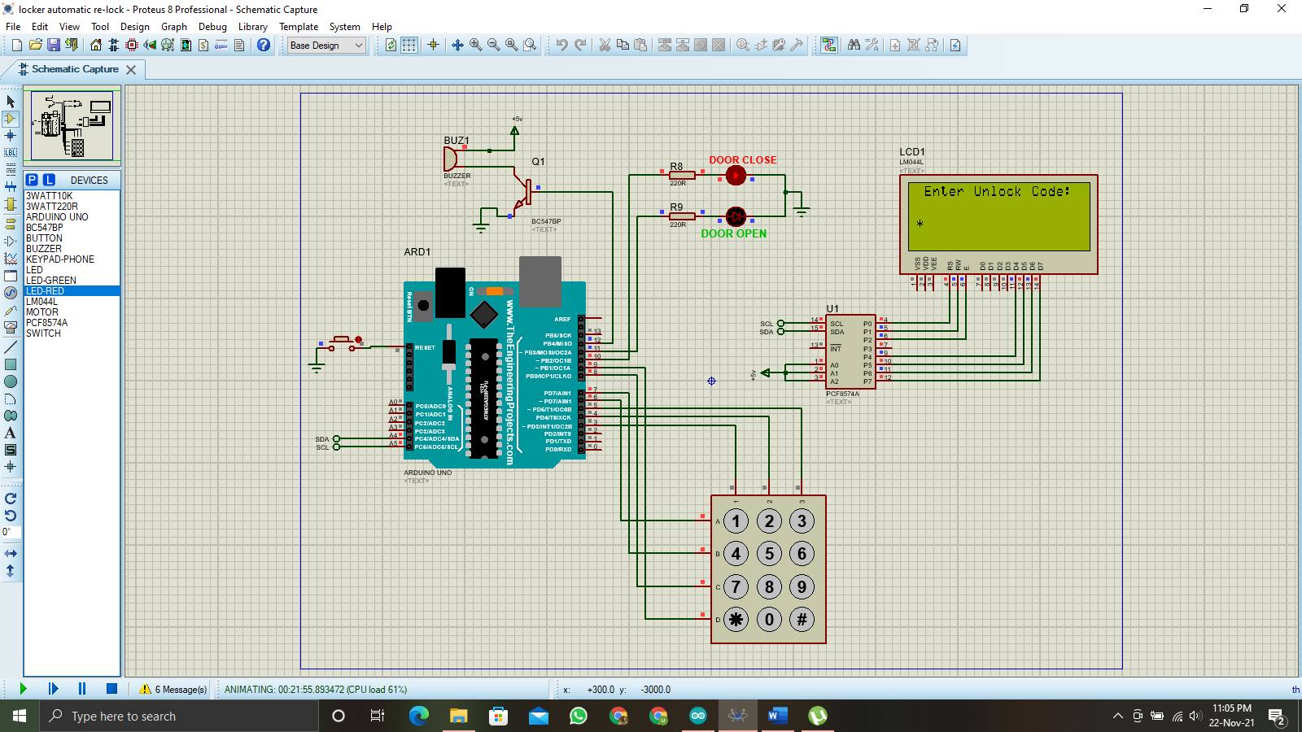

(image: 9)